1. PROJECT PROPOSAL

  - Background to the Problem
People today depend heavily on fast and dependable transportation. For business professionals, VIP clients, government officials, tourists, and travellers facing urgent situations, time matters more than ever. Helicopter services offer a practical solution because they avoid traffic and reduce long travel hours. Even so, many helicopter ride providers still rely on manual work or poorly connected systems, which causes serious operational problems.
Passengers often experience confusion during the booking process. Seat availability is not always clear, prices can feel uncertain, confirmations may take too long, and flight updates are sometimes missing. These small issues add up and reduce trust in the service. At the same time, operators face difficulties managing pilots, helicopters, maintenance schedules, and legal documents. When information is spread across different tools or handled manually, mistakes become more likely and coordination becomes harder.
Safety is another important concern. In emergency situations, every second counts. Quick communication and real-time tracking can save lives, yet traditional systems are often too slow or limited to support this properly. Managing passengers, pilots, operators, and emergency teams without a unified platform increases the risk of delays and miscommunication.
To address these challenges, a centralized system is needed—one that brings booking, payments, flight operations, tracking, maintenance, and emergency response into a single platform. Uthao – A Ride-Sharing Management System is proposed to meet this need by offering a secure, organized, and user-friendly solution designed specifically for helicopter ride-sharing services .

A/An  User Story Board:  Passenger | I want to | So that | Acceptance Criteria
 | Create an account | I can use the service | OTP sent to mobile/email for verification
 | Login | System verifies me | Successful login opens  homepage
 | Book a helicopter  ride | I can travel quickly | Booking confirmation via  SMS & app
 | View Flight Availability & Select Seat | I can choose the most suitable flight and seat. | The system displays real-time flight availability and available seats for selection.
 | Make digital payment | I can confirm my ride | Payment success  message & invoice shown
 | Track flight live | I know the helicopter status | Map shows real-time GPS
 | Modify or cancel booking | Plans may change | Refund processed automatically as per rules
 | Request for an emergency ride | I can get urgent transport | Immediate booking confirmation
 | Submit special requirements | Operator knows my needs | Special request saved with booking
 | Rate & review service | Experience improves | Rating stored in database
 | Logout | Account stays secure | Session ends successfully

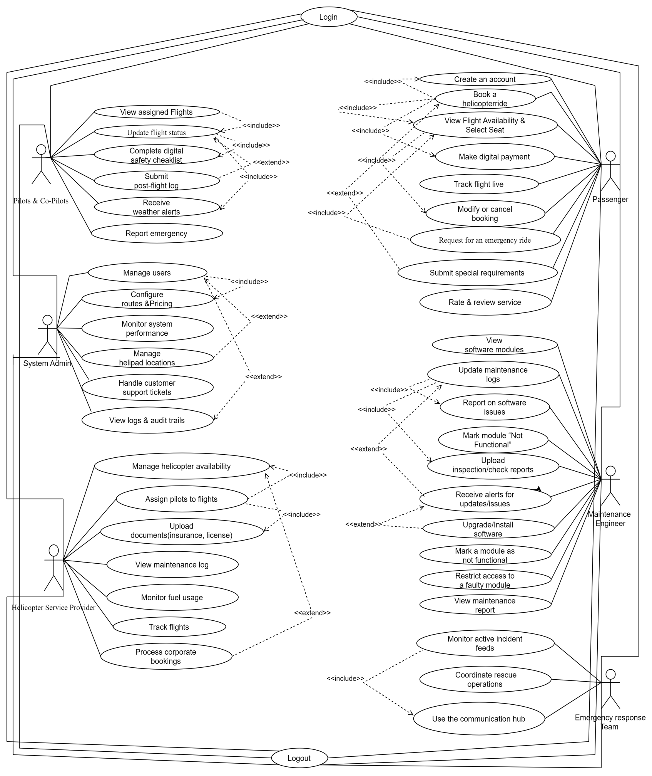
Use case Diagram:

